*Daniel Swain*

*PropertyDome | Perth, Western Australia*

*Final Project*

Assessment Four

Table of Contents

Introduction 3

Project Plan 3

Collaboration 3

*Collaboration Stats:* 3

Coding Standards: 6

Testing: 10

# **Introduction**

The following document outlines the final project project completion. It details the testing criteria as well as demonstrating compliance with our collaboration tools and coding standards.

# **Project Plan**

Please see the included Final Project Plan for an update of the project status, including final milestones, design decisions and functional requirements. Since the last project update on 21/04/2016 we have completed 2 additional sprints and have finished the development and delivery of the website in accordance with the functional requirements as listed in the Project Plan.

# **Collaboration**

For collaboration we are still using Trello, Slack and Github. We have found Slack to be the most used tool for discussion, with Github being useful for highlighting issues, bugs and feature requests. In the later sprints we started to use Github issues instead of Trello cards for tracking tasks for sprints as this integrated better with Github. For example, a user could reference their story/issue in their commit to track/tie the commit to that issue, making it easier to track.

## *Collaboration Stats:*

Commits to Project: 1034.

Git Issues: 1 Open (v2 feature list), 46 Closed (testing/bug reporting).

Pull Requests: 0 Open, 228 Closed.

Commits to Master: 632

Team Breakdown (commits to master, doesn’t include pull requests or issues):

Daniel: 230 Jayden: 175 Simon: 99 Michael: 90 Erdal: 35 Tylden: 3

Interesting tidbit: we managed to get a commit to the project during one of all 24 hours of the day, with our biggest times being 1pm, 3pm, 11pm and 1am.

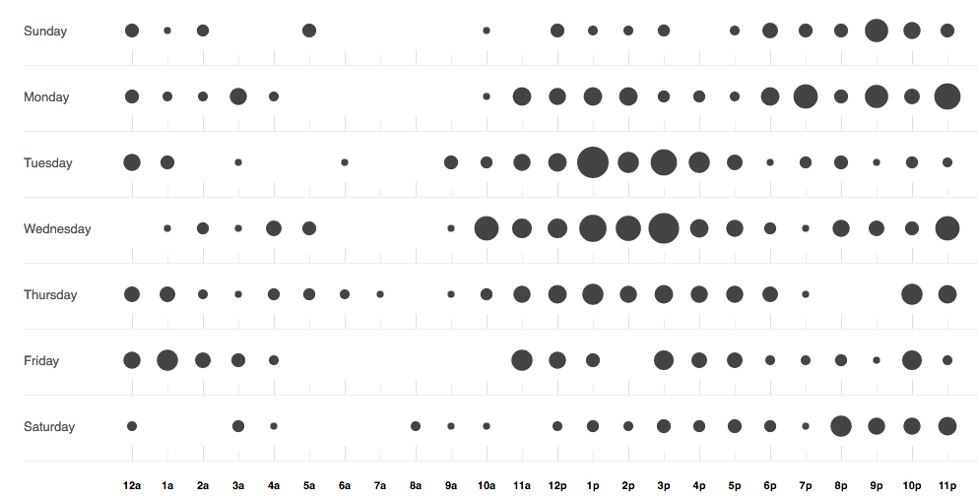

The following are examples of the collaboration tools being used:

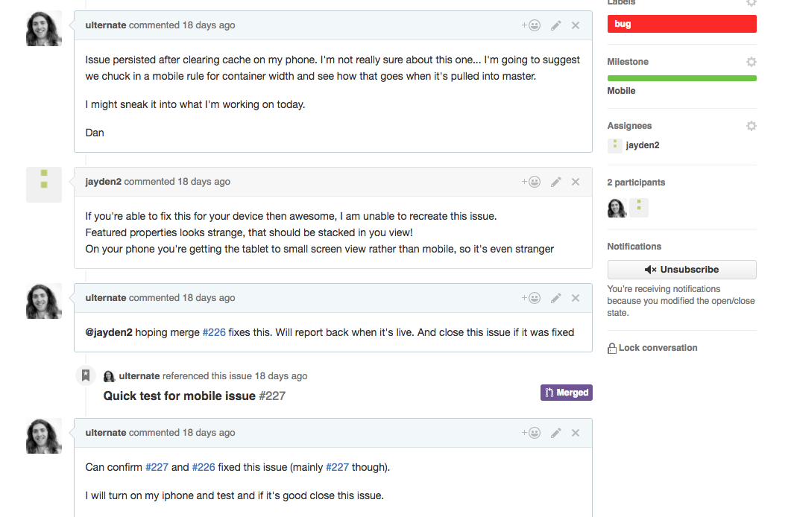

Github Issues being used to pinpoint bugs/issues in site features.

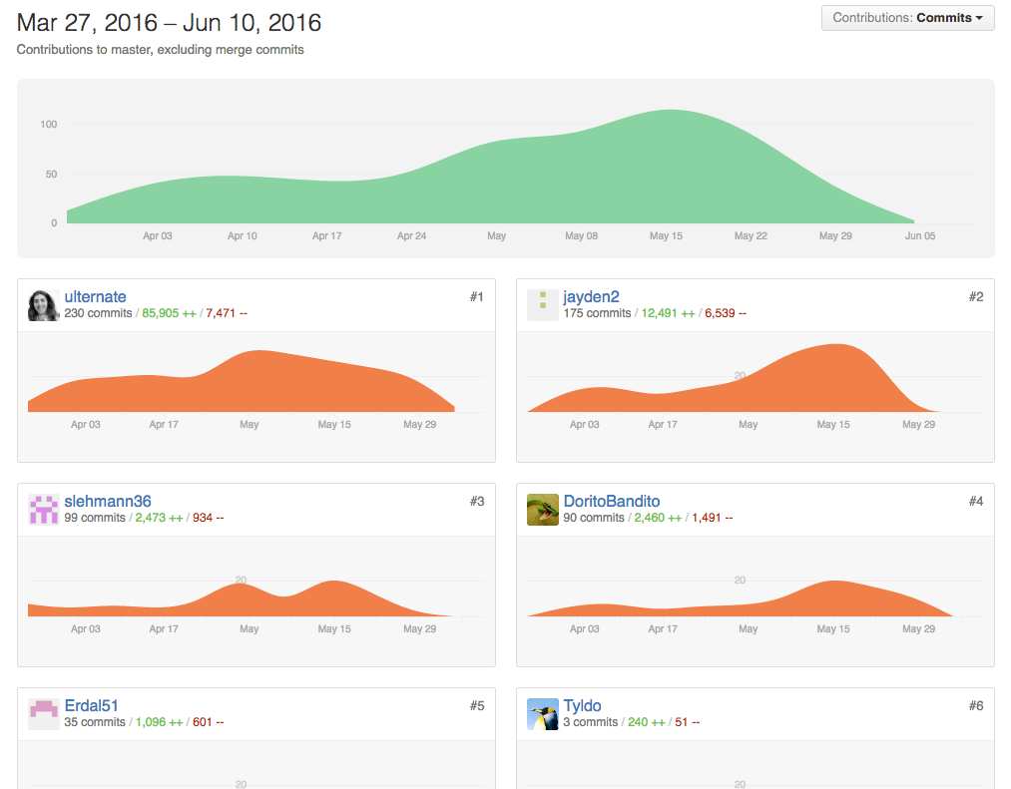

Screenshot of the project on Github, showing commits to master from team members. Apart from a few outliers, contribution to the project was fairly even and consistent from all members.

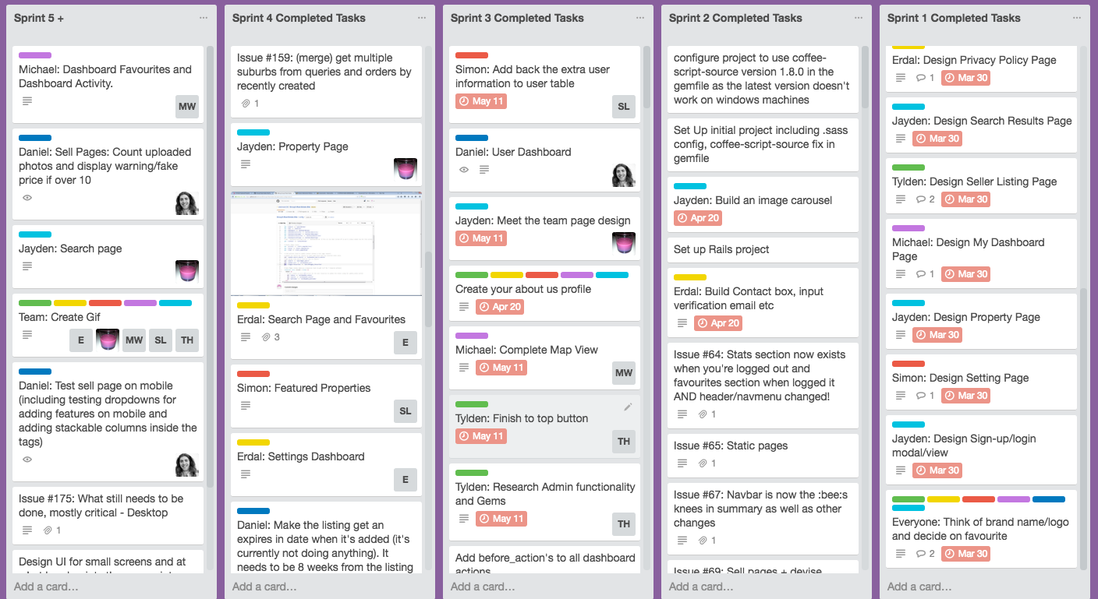

Screenshot showing Trello tracking completed sprint tasks and issues.

# **Coding Standards:**

The coding standards we implemented can be found here: <https://drive.google.com/open?id=18F52kEOdb0eG1TtQPi_kskgJIjToppe2-23_J8VWmzw>

The following images demonstrate these coding standards being followed in various languages:

Image 1 – sell_controller.rb:

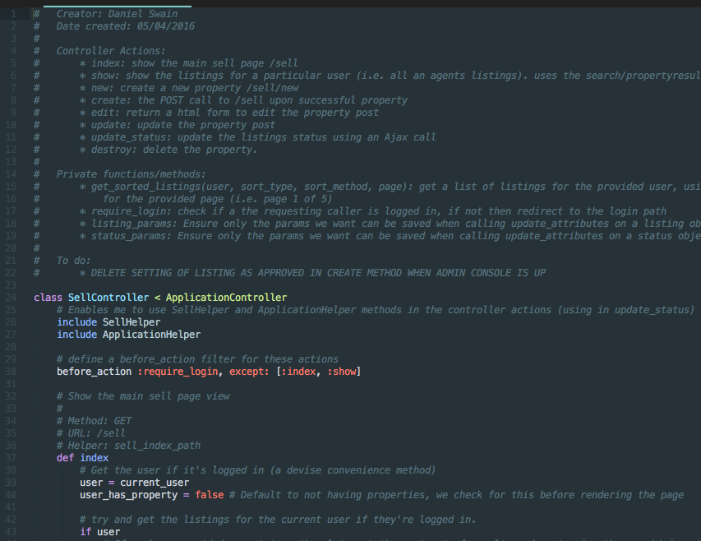

Notes:

* Documented with creator, date, action explanation and todo
* Aligned in accordance with coding standard
* Variables named in accordance with coding standard (snake_case)
* NB (the database column names were created using CamelCase)

Image 2 – _sell.sass:

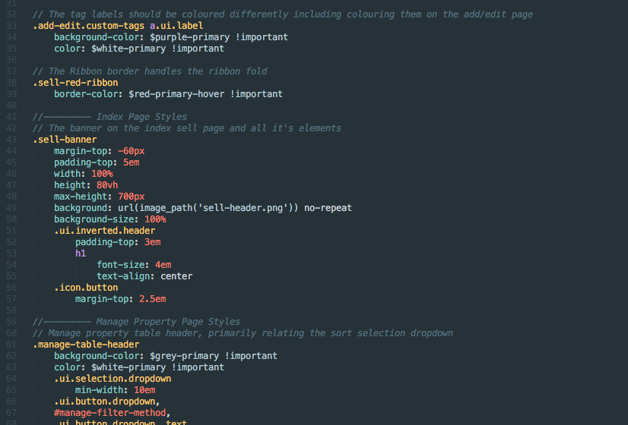

Notes:

* Documented with explanations for style definitions
* Aligned in accordance with coding standard
* Using correct variables for global variables like colours (colour-shade-action)
* Using ‘em’s as much as possible (unavoidable for the banner height and top margin)

Image 3 – manage.html.erb:

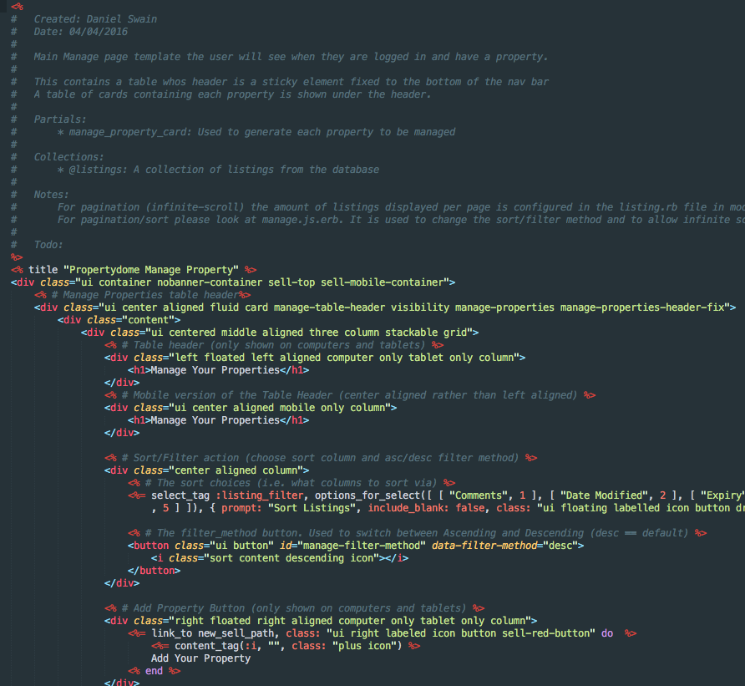

Notes:

* Documented with creator, date, partials/dependencies, explanations and todo
* Aligned in accordance with coding standard
* Using snake_case for ruby variables and hyphen for html id’s/classes

Image 4 – add_edit.coffee:

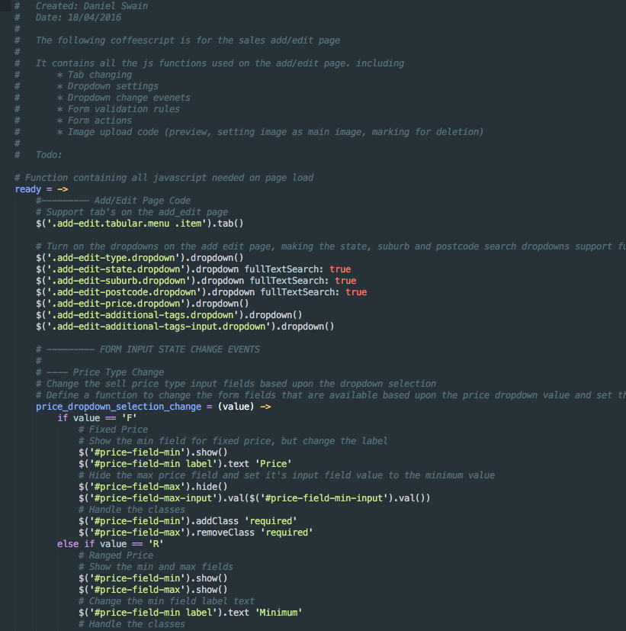

Notes:

* Documented with creator, date, explanations and todo
* Aligned in accordance with coding standard
* Single quotes used for variable/JQuery selectors

# **Testing:**